## Module 7 Network fundamentals

### • Advance Question

1. Explain Network Topologies

Ans- 1. Bus Topology:

Bus topology is a type of network topology in which all devices are connected to a single cable called a "bus."

2.Ring Topology:

Ring topology is a type of network configuration where devices are connected in a circular manner, forming a closed loop.

3.Mesh Topology:

A mesh topology is a type of computer network in which each node is connected to every other node in the network.

4.Tree Topology:

In networking, tree topology is a structure where devices are connected hierarchically. It resembles a tree with a root node and various branches. The root node is connected to multiple levels of child nodes, forming a hierarchy.

5.Star Topology:

Star topology is a network topology in which each network component is physically connected to a central node such as a router, hub or switch.

6.Hybrid Topology:

hybrid topology is a type of network topology in which two or more different topologies are integrated or combined to lay out a network.

1. Explain TCP/IP Networking Model?

Ans- TCP and IP are two separate computer network protocols. IP is the part that obtains the address to which data is sent. TCP is responsible for data delivery once that IP address has been found. It's possible to separate them, but there isn't really a point in making a difference between TCP and IP.

1. Explain LAN and WAN Network?

Ans- LAN means local area network. WAN means wide area network. LANs connect users and applications in close geographical proximity same building. WANs connect users and applications in geographically dispersed locations across the globe.

1. Explain Operation of Switch?

Ans- Switches may be operated by process variables such as pressure, temperature, flow, current, voltage, and force, acting as sensors in a process and used to automatically control a system. For example, a thermostat is a temperature-operated switch used to control a heating process.

1. Describe the purpose and functions of various network devices?

Ans- A network device is a node in the wireless mesh network. It can transmit and receive wireless HART data and perform the basic functions necessary to support network formation and maintenance.

1. Make list of the appropriate media, cables, ports, and connectors to connect switches to other?

Ans- The transmission media is mainly of two types: Wired Media and Wireless Media

Network cables can be divided into four types: coaxial, shielded twisted pair (STP), unshielded twisted pair (UTP), or fibre optic.

In the computer there are many ports are there: USB, HDMI, RJ45, Serial, Parallel, Audio.

1. Define Network devices and hosts?

Ans- A network device is a piece of hardware or software integral to communication between a computer and an internet network.

A host is a computer or other device that communicates with other hosts on a network. Also known as network hosts

1. What are Ethernet Standard (802.3) and Frame Formats?

Ans- It is also known as Ethernet RAW or Ethernet 802.3. IEEE 802.3 frames have a fixed header size of 14 bytes and a variable payload size of up to 1492 bytes. The header consists of six bytes for the destination address, six bytes for the source address, and two bytes for the length field.

Ther Type is a two-octet field in an Ethernet frame.

### • Intermediate Question

1. Comparison between UTP, MM and SM Ethernet Cabling?

Ans: done

1. Make Cross cable?

Ans: done

1. Make Straight-Through Cable?

Ans: done

1. Differentiate between LAN/WAN operation and features

Ans: LANs use local connections like ethernet cables and wireless access points. WANs use wide area connections like MPLS, VPNs, leased lines, and the cloud. LANs are faster, because they span less distance and have less congestion. WANs are slightly slower, but that may not be perceived by your users.

1. Explain ARP, ICMP and Domain name?

Ans- Address Resolution Protocol (ARP) is a protocol that maps dynamic IP addresses to permanent physical machine addresses in a local area network (LAN). The physical machine address is also known as a media access control (MAC) address.

The Internet Control Message Protocol (ICMP) is a protocol that devices within a network use to communicate problems with data transmission.

A domain name is an easy-to-remember name that's associated with a physical IP address on the Internet.

1. Describe the components required for network and Internet communications?

Ans- Some important network components are NIC, switch, cable, hub, router, and modem.

1. Explain Encapsulation and DE capsulation in OSI Reference model?

Ans- Encapsulation adds information to a packet as it travels to its destination. Decapsulation reverses the process by removing the info, so a destination device can read the original data. Many people take networks for granted despite the significant roles they play in our daily lives.

1. Explain network segmentation and basic traffic management concepts?

Ans- Network segmentation is an architectural approach that divides a network into multiple segments or subnets, each acting as its own small network.

1. What is flow control and acknowledgment**?**

Ans- The purpose of flow control is to throttle the amount of data transmitted to avoid overwhelming the receiver's resources

a signal that is passed between communicating processes, computers, or devices to signify acknowledgment, or receipt of message, as part of a communications protocol it’s called acknowledgment.

### • Advance question

1. Use the OSI and TCP/IP models and their associated protocols to explain how data Flows in a network?

Ans- Data Generation:

Application Layer generates data.

Encapsulation:

The data is encapsulated at each layer with relevant headers or trailers.

Transmission:

The encapsulated data is transmitted over the network medium.

Decapsulation:

At the receiving end, each layer extracts and processes its specific header or trailer.

Delivery to Application:

Finally, the data is delivered to the destination application at the Application Layer.

1. Identify and explain at layers 1, 2, 3, and 7 using a layered model approach?

Ans- Layer 1 - Physical Layer:

Responsible for converting digital data into electrical/optical signals for transmission.

Involves specifications for physical media, like Ethernet cables or fiber optics.

Layer 2 - Data Link Layer:

Frames data into packets and adds source/destination MAC addresses.

Performs error checking to ensure data integrity.

Layer 3 - Network Layer:

Involves IP addressing and routing protocols (e.g., IP, ICMP, OSPF).

Handles logical addressing and packet forwarding.

Layer 7 - Application Layer:

Hosts application-specific protocols (e.g., HTTP, FTP, SMTP).

Interacts with software applications and end-users.

1. Explain CSMA/CD and CSMA/CA?

Ans- CSMA/CD (Carrier Sense Multiple Access with Collision Detection):

CSMA/CD is a network protocol used in Ethernet networks to manage how devices contend for access to the shared communication medium.

CSMA/CA (Carrier Sense Multiple Access with Collision Avoidance):

CSMA/CA is a protocol used in wireless networks, such as Wi-Fi, where the nature of the medium makes collision detection difficult or impractical.

1. Explain this frame and find layer?

Ans – To explain a frame, we need specific information about its content, but generally, a frame is a data unit at the data link layer (Layer 2) of the OSI model or the Link Layer in the TCP/IP model, encapsulating data with headers and trailers for transmission over a network

1. Draw and explain Cisco hierarchical model?

Ans- The Hierarchical internetworking model is a three-layer model for network design first proposed by Cisco in 1998. The hierarchical design model divides enterprise networks into three layers: core, distribution, and access.

+---------------------+

| Core Layer |

+---------------------+

/ \

/ \

/ \

/ \

+---------------------+

| Distribution Layer |

+---------------------+

| |

+-----+ +-----+

|Access| |Access|

+-----+ +-----+

| |

End Device End Device

1. Drawing of a typical wired and wireless enterprise LAN?

Ans-

Typical wired enterprise LAN:

Internet

|

Router

|

Firewall

|

Distribution Switch

/ | \

Access Access Access

Switch Switch Switch

| | | |

PC PC Printer Server

Typical wireless enterprise LAN:

Internet

|

Router

|

Firewall

|

Wireless Controller

|

Distribution Switch

/ | \

Wireless AP Access Switch Access Switch

| |

End Devices (PCs, Printers)

1. Describe the uses of straight-through and crossover Ethernet cables?

Ans- straight-through cable when you want to connect two devices of different types. You should use a crossover cable when you want to connect two devices of the same type.

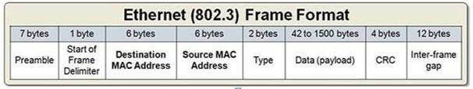

1. Explain Layer 2 and Layer 3 Switch?

Ans- Layer 2 switches are often used to reduce data traffic on a LAN. Because they use MAC addresses only, an unidentified device attempting to use the network will be denied. On the other hand

Layer 3 switches are primarily used to operate VLANs and improve security.

1. Identifying Collision and Broadcast Domains?

Ans- C

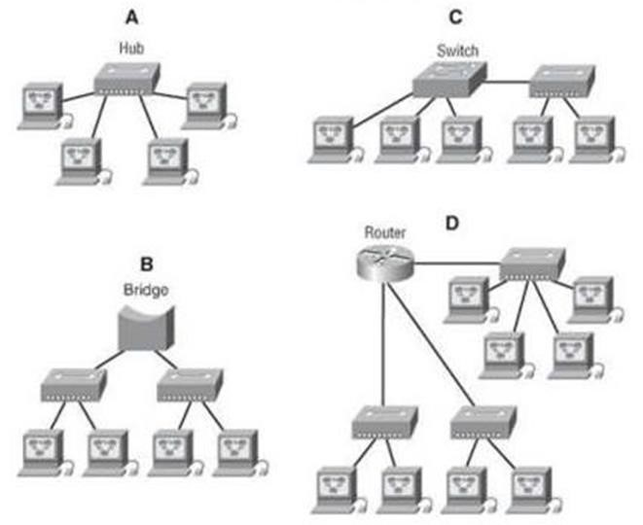

1. Explain Spanning Tree Protocol?

Ans- Spanning Tree Protocol (STP) is a Layer 2 protocol that runs on bridges and switches. The specification for STP is IEEE 802.1D. The main purpose of STP is to ensure that you do not create loops when you have redundant paths in your network.

1. Explain uncast Multicast and Broadcast?

Ans- Unicast, multicast, and broadcast are address types.

A unicast address represents a single interface.

A multicast address represents a group of interfaces.

A broadcast address represents all interfaces of the local network.

1. Explain CAM (Content Addressable Memory)?

Ans- Content-addressable memory (CAM) is a special type of computer memory used in certain very-high-speed searching applications. It is also known as associative memory or associative storage and compares input search data against a table of stored data, and returns the address of matching data.

1. Explain TCAM (Ternary Content Addressable Memory)?

Ans- Ternary content-addressable memory (TCAM) is a specialized type of high-speed memory that searches its entire contents in a single clock cycle.

1. Which command use of Show MAC TABLE?

Ans- Show mac address table